**Online Reporting Portal**

Documentation

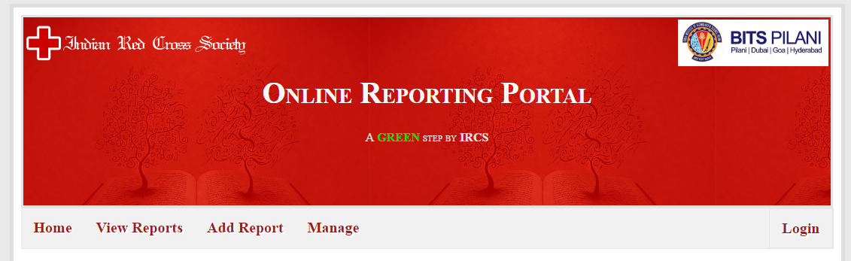

Some Basic Information:

A report can have any one of the following status:

1. Not Sent
2. Awaiting District Approval
3. Awaiting State Approval
4. Awaiting National Approval
5. Rejected
6. Verified

A user can be of 2 types

1. Reporter
2. Verifier

A user can have 3 levels

1. National
2. State
3. District

Home

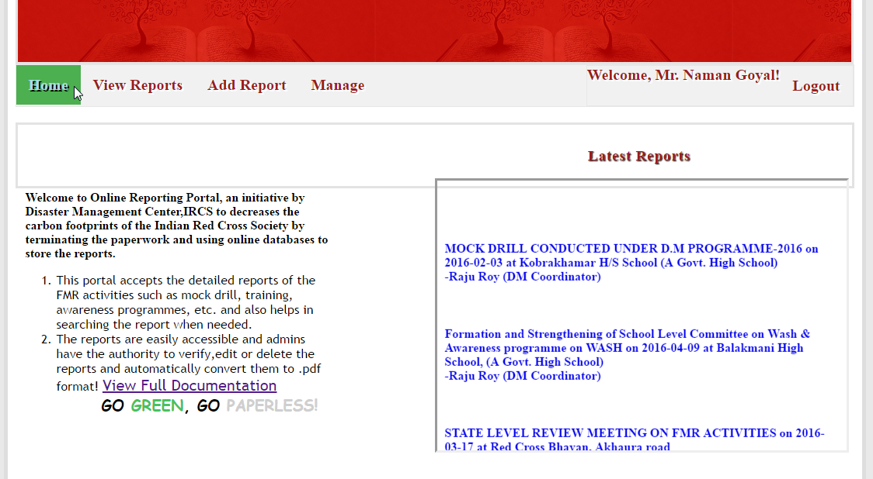

* Latest reports section will show 3 latest reports (clicking on which will display full report) added to the portal.
* View full documentation link provided for reference to the users

View Reports

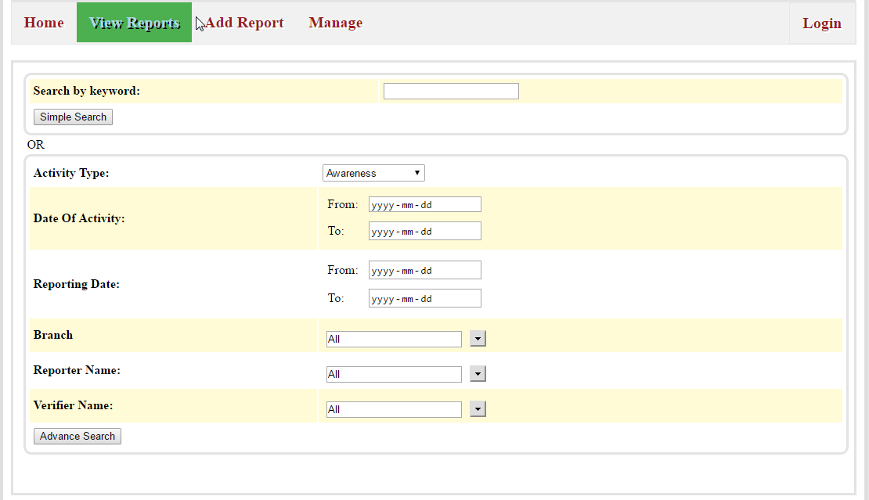

* Reports can be searched on the basis of keyword, keyword could be a phrase in activity-type, branch, reporter name, verifier name, or a phrase in report title.(like ‘**awa**’ will display all the results with activity type ‘**awa**reness’ or reporter/verifier name as ‘**awa**sthi’).For more accurate results type more precise phrases.(keyword is case-Insensitive)
* Advance search feature has also been provided.(refer the image above)
* For Instance, I search for a report with keyword ‘awareness’. Result will be displayed as follows.

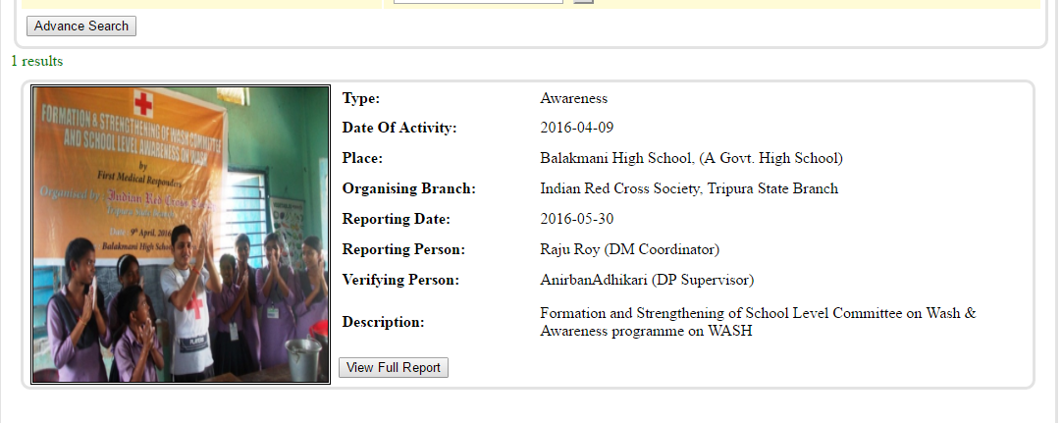

Then Click on View full report button….

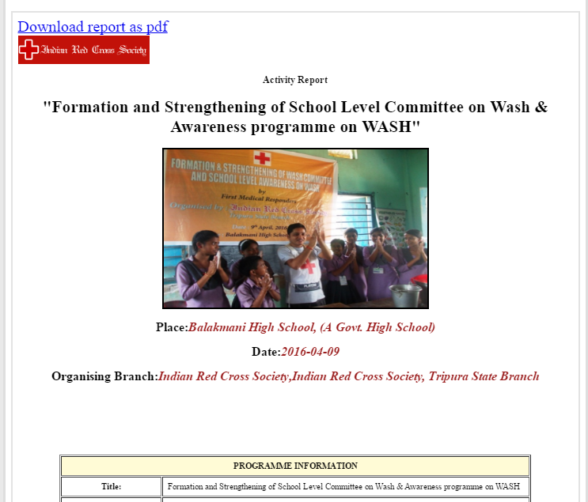

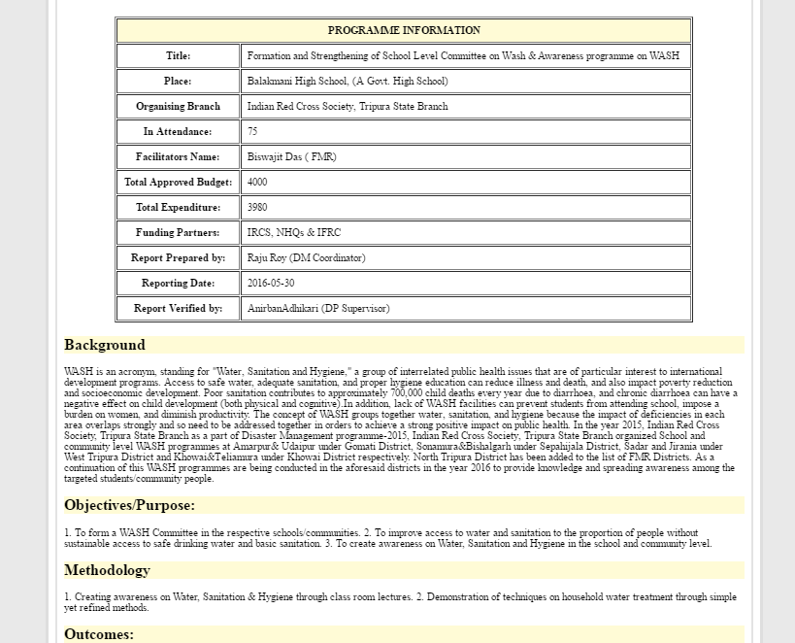…

Add Report

This link won’t work if

* You are a verifier, because only a reporter can add a report
* You are a reporter but there are no verifiers at your level in your state. For e.g. if you are a district reporter of Ludhiana and there is no district verifier of Ludhiana then this link won’t work.

Brief Overview

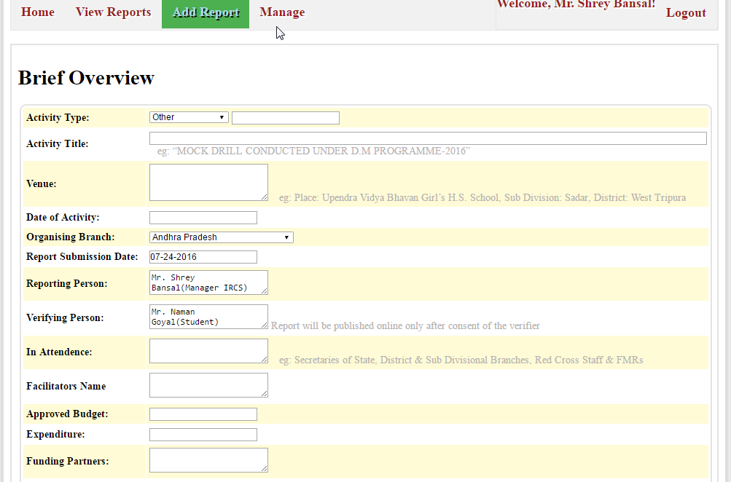

1. Reporting Person name is the username who has logged in.
2. Verifying person name will come automatically depending on your level, state, district.
3. Report submission date is fixed as today’s date
4. In case of district or state reporter organizing branch is fixed

Detailed Analysis:

1. Text box has been provided, all the formatting done in textbox will be reflected in the final report too.(spacing,alignment etc).

Now you must click on save and choose files to upload button to save current data and proceed to next section(at this stage your report status will become ‘Not Sent’ which means your current session has been saved, you can still make changes to your report by going to Manage->Reports section before sending it for verification)

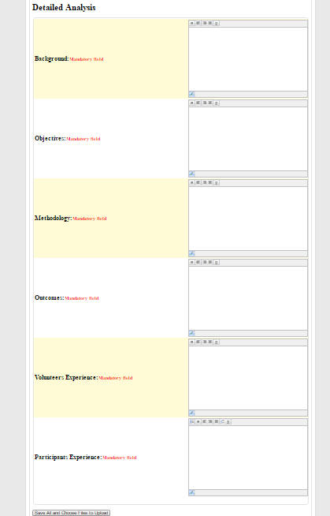

After clicking ‘Save all and choose files to upload button’…

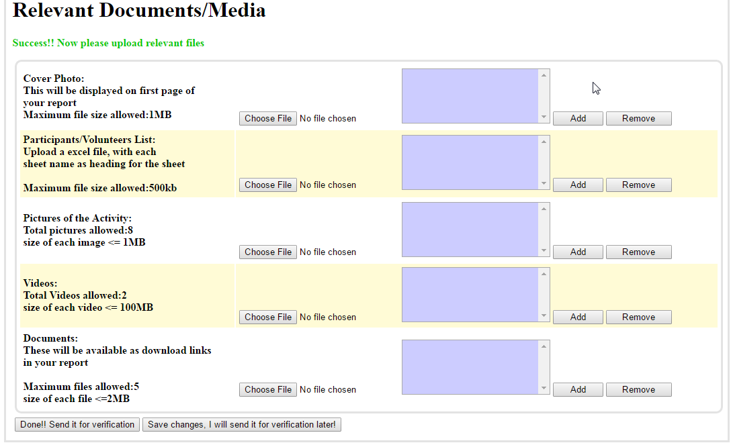

Please stick to the limits, uploaded files are showed in listbox, which can later be removed

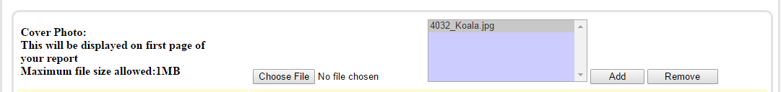

Track upload progress in lower left corner of your screen 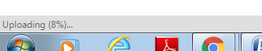

Manage Reports

Reports with status ‘Not Sent’ will appear hear, which can be edited/deleted before sending it for verification.

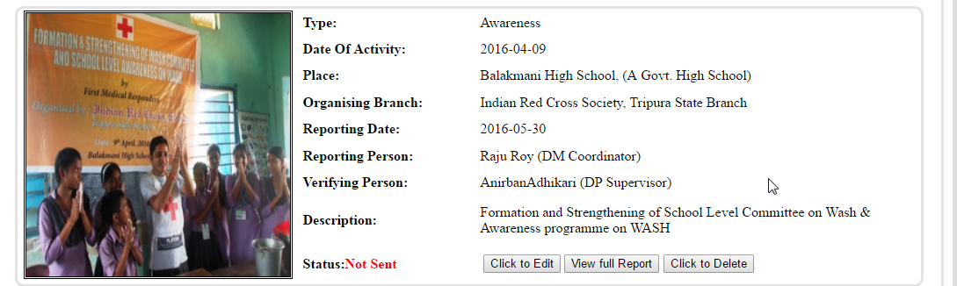

What happens after a report is submitted for verification?

Once a report is sent for verification, it cannot be further edited/deleted by the reporter only verifier can do that

Simply follow the arrow, once the report is verified by National Verifier it becomes public, then it cannot be edited/deleted by any user.

Manage Users

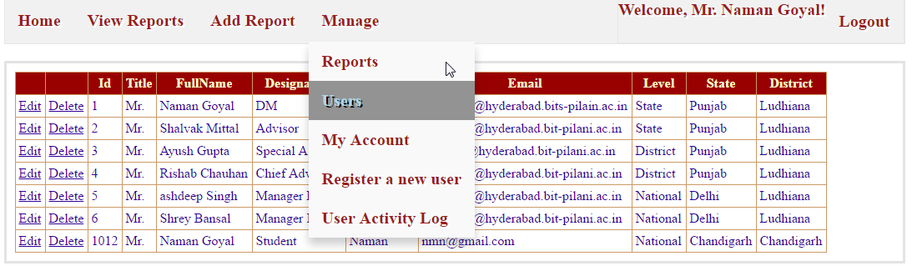

Currently National user can create other National, State, District users and State User can create other state, district users of his/her state only

Manage Register a new User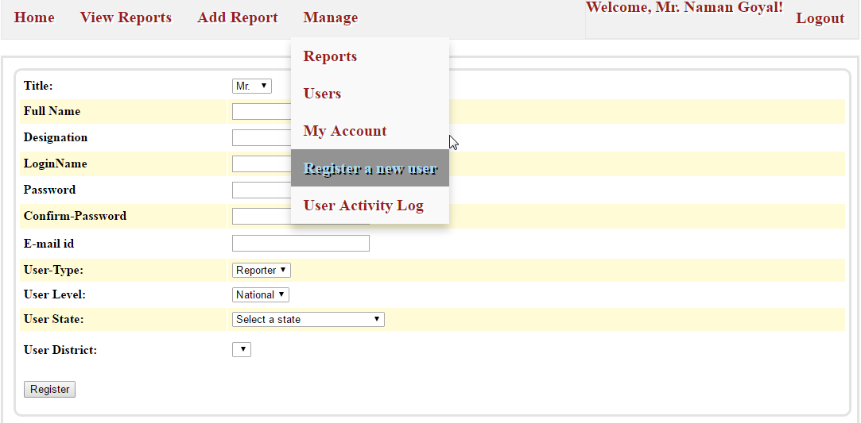

Manage My Account

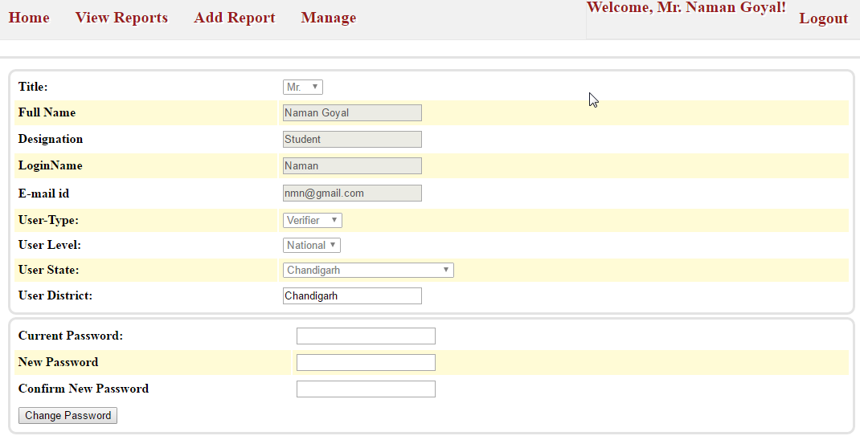

Manage User activity log

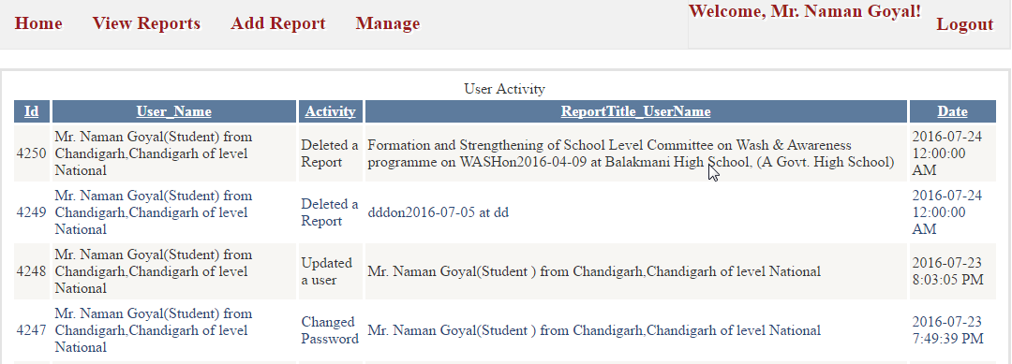

For transparency User Activity Log(accessible to all users) has been provided

**NOTIFICATIONS**

In case you are a verifier and have reports waiting to be verified



Click on the link to see the report:

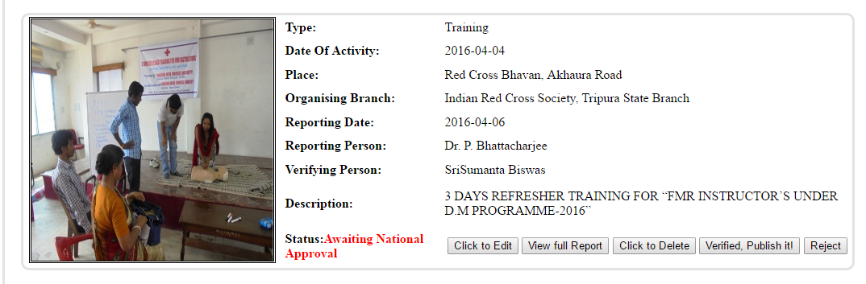

In case your report(which had been sent for verification )has been rejected by the verifier



In case your report(which had been sent for verification ) has not yet been verified

click on the link to see its status

